Attorney general laxalt’s
2017 AG FOR A DAY
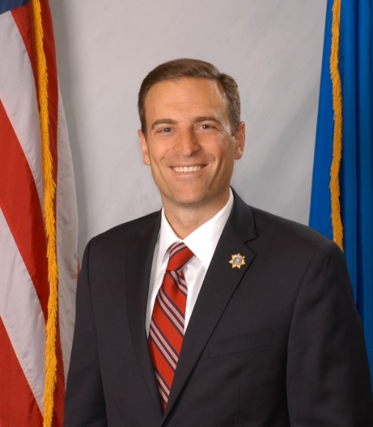
The “AG for a Day” tour is designed to take state government directly to the people of Nevada’s communities. Beginning on June 8th in Ely, AG Laxalt will tour Nevada’s cities and counties accompanied by various members of his staff who represent major divisions in state government.
Collectively, AG Laxalt and members of the office will present on topics including free civil legal services for our military, public lands, guardianship and elder exploitation, taxation, consumer fraud, senior safety tips, identity theft, domestic violence and services for victims. Following the presentations, AG Laxalt and his staff will listen to the concerns of residents and be available to answer any questions.
HISTORY
In November of 1968, Nevada Governor Paul Laxalt embarked on a Capital for a Day tour with members of his cabinet to identify concerns and create responsive solutions for the State.
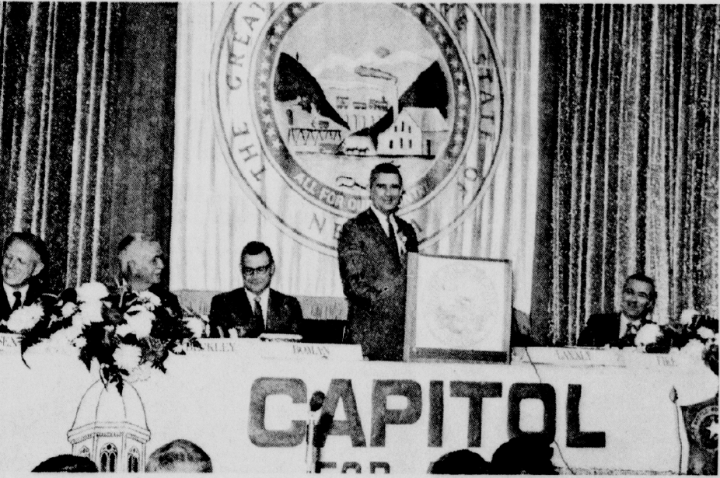
In the spirit of Governor Laxalt’s Capital for a Day tour, AG Laxalt launched the “AG for a Day” tour in September of 2016, where he and members of his staff successfully met with Nevadans in 16 counties and cities.
“Last year’s ‘AG for a Day’ tour afforded my office the unique opportunity to interact with Nevadans all over the State and to discuss the services we offer. Ensuring that my office can be responsive to the needs of our constituents and be of assistance is the ultimate goal of this tour. Based on the feedback from last year, we are excited to launch a new series of informational presentations on this year’s tour, and hope that Nevadans will take advantage of this opportunity and join us at our stops.” – AG adam laxalt
MORE INFORMATIOn: ag.nv.gov
ELKO stop
6/22/17: Elko
11:45 a.m. Great Basin College Elko Campus
1500 College Parkway
Room GTA-130

