**2021 Services-Training-Officers-Prosecutors (STOP) and**

**Sexual Assault Services Program (SASP) Solicitation**

**Questions and Answers**

**Question 1: We are considering starting our batterer’s treatment program for those sentenced to counseling by the courts.  Is this something that VAWA funds would support?**

*Answer 1: Yes. Batterers’ intervention programs may be supported provided that the programs use court monitoring to hold offenders accountable for their behavior. However, couples counseling or any intervention that requires participation by a victim or that is not designed to hold offenders accountable for their violent behavior cannot be supported with STOP dollars.*

*\*\*\*\*\*\*\*\*\*\*\*\*\*\*\*\*\*\*\*\*\*\*\*\*\*\*\*\*\*\*\*\*\*\*\*\*\*\*\*\*\*\*\*\*\*\*\*\*\*\*\*\*\*\*\*\*\*\*\*\*\*\*\*\*\*\*\*\*\*\*\*\*\*\*\*\*\*\**

**Question 2: We are in the process of seeing what it would take to launch a Batterer Intervention Program (BIP). Could STOP funds be used to obtain training and other certifications to initiate the launching of this program, or would the BIP program already need to be fully established to request STOP/SASP funding support?**

*Answer 2: Yes. Batterers’ intervention programs may be supported provided that the programs use court monitoring to hold offenders accountable for their behavior. However, couples counseling or any intervention that requires participation by a victim or that is not designed to hold offenders accountable for their violent behavior cannot be supported with STOP dollars.*

*\*\*\*\*\*\*\*\*\*\*\*\*\*\*\*\*\*\*\*\*\*\*\*\*\*\*\*\*\*\*\*\*\*\*\*\*\*\*\*\*\*\*\*\*\*\*\*\*\*\*\*\*\*\*\*\*\*\*\*\*\*\*\*\*\*\*\*\*\*\*\*\*\*\*\*\*\*\**

**Question 3: I have a question about Attachment J. Certificates of Liability Insurance, if applicable. Do victim service agencies need to submit this document?**

*Answer 3: Yes.*

*\*\*\*\*\*\*\*\*\*\*\*\*\*\*\*\*\*\*\*\*\*\*\*\*\*\*\*\*\*\*\*\*\*\*\*\*\*\*\*\*\*\*\*\*\*\*\*\*\*\*\*\*\*\*\*\*\*\*\*\*\*\*\*\*\*\*\*\*\*\*\*\*\*\*\*\*\*\**

**Question 4: Can we get the FY 21-22 VAWA Application Sample Cost Allocation Plan unlocked? We aren't able to annotate it.**

*Answer 4: This form is just a sample.  You can submit your cost allocation any way you want as long as it has the same information.*

*\*\*\*\*\*\*\*\*\*\*\*\*\*\*\*\*\*\*\*\*\*\*\*\*\*\*\*\*\*\*\*\*\*\*\*\*\*\*\*\*\*\*\*\*\*\*\*\*\*\*\*\*\*\*\*\*\*\*\*\*\*\*\*\*\*\*\*\*\*\*\*\*\*\*\*\*\*\**

**Question 5: Does the cost allocation table need to cover the entire agency’s budget or just the proposed budget?**

*Answer 5: The cost allocation table only needs to cover the proposed budget.*

*\*\*\*\*\*\*\*\*\*\*\*\*\*\*\*\*\*\*\*\*\*\*\*\*\*\*\*\*\*\*\*\*\*\*\*\*\*\*\*\*\*\*\*\*\*\*\*\*\*\*\*\*\*\*\*\*\*\*\*\*\*\*\*\*\*\*\*\*\*\*\*\*\*\*\*\*\*\**

**Question 6: Are Letters of Support encouraged or allowed?**

*Answer 6: Letters of Support can be included but we are not able to add points for it since we did not include it as a requirement in the solicitation.*

*\*\*\*\*\*\*\*\*\*\*\*\*\*\*\*\*\*\*\*\*\*\*\*\*\*\*\*\*\*\*\*\*\*\*\*\*\*\*\*\*\*\*\*\*\*\*\*\*\*\*\*\*\*\*\*\*\*\*\*\*\*\*\*\*\*\*\*\*\*\*\*\*\*\*\*\*\*\**

**Question 7: Is the budget form the same as last year’s budget form?**

*Answer 7: Yes.*

*\*\*\*\*\*\*\*\*\*\*\*\*\*\*\*\*\*\*\*\*\*\*\*\*\*\*\*\*\*\*\*\*\*\*\*\*\*\*\*\*\*\*\*\*\*\*\*\*\*\*\*\*\*\*\*\*\*\*\*\*\*\*\*\*\*\*\*\*\*\*\*\*\*\*\*\*\*\**

**Question 8: Can I get the budget form for the FY STOP application in Excel or Word?  I also wanted to make sure the documents I am downloading for the application are the current ones for FY 21 even though they have 2018 in the file names.**

*Answer 8: Unfortunately, we don’t have the form in Excel or Word but I attached 2 versions of the PDF.  The first attachment is the fillable form and the second attachment is a scanned version that you can type/write on.  While the budget form and others may have an expiration date on them, that is okay.*

*Just to make sure, are you downloading the forms from our ag.nv.gov/grants/grants/ website in this section:*

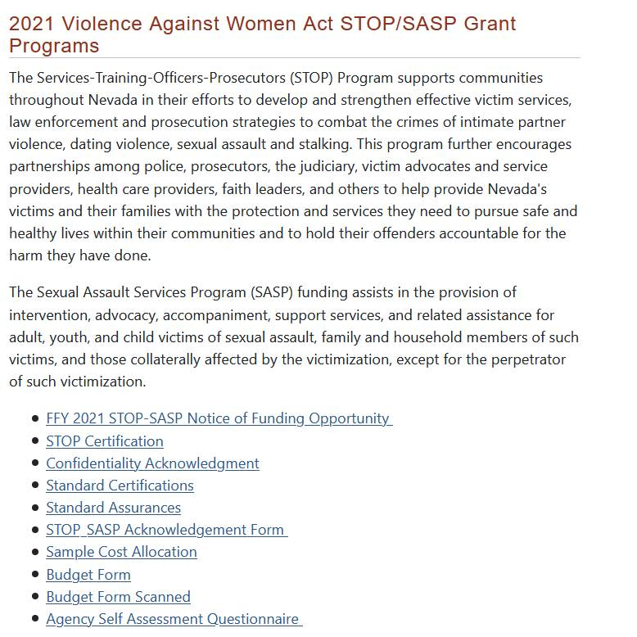

*\*\*\*\*\*\*\*\*\*\*\*\*\*\*\*\*\*\*\*\*\*\*\*\*\*\*\*\*\*\*\*\*\*\*\*\*\*\*\*\*\*\*\*\*\*\*\*\*\*\*\*\*\*\*\*\*\*\*\*\*\*\*\*\*\*\*\*\*\*\*\*\*\*\*\*\*\*\**

**Question 9: I have a question about Attachment B, the VAWA 2021 Program Grant Certification of Nondiscrimination (Page 28), that references the governing body's review of the grant and review and understanding of the nondiscrimination policy.  I was wondering whether: (a) this is required for nonprofit organizations rather than local government entities, and if not (b) whether this could be signed at the time of award acceptance.  Any grant award is brought to the City Council for acceptance, and authorization of the Mayor, City Manager, and/or Chief to sign this award document.  We could include this certification with the award for City Council review and action.  Unfortunately, it takes at least a month, if not more, to get on a Council agenda, so we cannot provide it at the time of application.**

*Answer 9: For the Certificate of Non-Discrimination, it is required for all applicants and we would need it to be included as part of the application package.  You may not need the Mayor or City Council to sign this document though and it could be signed by the Chief/an authorized official. \*\*\*\*\*\*\*\*\*\*\*\*\*\*\*\*\*\*\*\*\*\*\*\*\*\*\*\*\*\*\*\*\*\*\*\*\*\*\*\*\*\*\*\*\*\*\*\*\*\*\*\*\*\*\*\*\*\*\*\*\*\*\*\*\*\*\*\*\*\*\*\*\*\*\*\*\*\**

**Question 10: What is the total amount of funding made through this opportunity?**

*Answer 10: We have not been notified of our funding amounts yet but we anticipate it will be similar to our current awards in which approximately $1.4million to $1.5million will be allocated for STOP and approximately $400,000 will be allocated for SASP.*

*\*\*\*\*\*\*\*\*\*\*\*\*\*\*\*\*\*\*\*\*\*\*\*\*\*\*\*\*\*\*\*\*\*\*\*\*\*\*\*\*\*\*\*\*\*\*\*\*\*\*\*\*\*\*\*\*\*\*\*\*\*\*\*\*\*\*\*\*\*\*\*\*\*\*\*\*\*\**

**Question 11: What is the total amount that the State will receive?**

*Answer 11: We have not been notified of our funding amounts yet but we anticipate it will be similar to our current awards of approximately $1.7 million for STOP and about $410,000 for SASP.*

*\*\*\*\*\*\*\*\*\*\*\*\*\*\*\*\*\*\*\*\*\*\*\*\*\*\*\*\*\*\*\*\*\*\*\*\*\*\*\*\*\*\*\*\*\*\*\*\*\*\*\*\*\*\*\*\*\*\*\*\*\*\*\*\*\*\*\*\*\*\*\*\*\*\*\*\*\*\**

**Question 12: How much does the State keep for Administration? Is it 10%?**

*Answer 12: For STOP, it is 10% and for SASP, it is 5%.*

*\*\*\*\*\*\*\*\*\*\*\*\*\*\*\*\*\*\*\*\*\*\*\*\*\*\*\*\*\*\*\*\*\*\*\*\*\*\*\*\*\*\*\*\*\*\*\*\*\*\*\*\*\*\*\*\*\*\*\*\*\*\*\*\*\*\*\*\*\*\*\*\*\*\*\*\*\*\**

**Question 13: Can we submit the application in PDF format in separate files, labeling Part 1 of 2, Part 2 of 2, etc.?**

*Answer 13: Yes.*

*\*\*\*\*\*\*\*\*\*\*\*\*\*\*\*\*\*\*\*\*\*\*\*\*\*\*\*\*\*\*\*\*\*\*\*\*\*\*\*\*\*\*\*\*\*\*\*\*\*\*\*\*\*\*\*\*\*\*\*\*\*\*\*\*\*\*\*\*\*\*\*\*\*\*\*\*\*\**

**Question 14: We are preparing our budget for next year and are wondering if there will be VAAN Training?**

*Answer 14: Yes, VAAN is anticipated to be hosted virtually in October 2021.*

*\*\*\*\*\*\*\*\*\*\*\*\*\*\*\*\*\*\*\*\*\*\*\*\*\*\*\*\*\*\*\*\*\*\*\*\*\*\*\*\*\*\*\*\*\*\*\*\*\*\*\*\*\*\*\*\*\*\*\*\*\*\*\*\*\*\*\*\*\*\*\*\*\*\*\*\*\*\**

**Question 15:** I want to confirm that, on the last page of the budget form, Federal Funds is the amount of grant funds I am requesting, Non-Federal Funds is the match and Total is the total project cost of federal funds and match together?

*Answer 15: Yes.*

*\*\*\*\*\*\*\*\*\*\*\*\*\*\*\*\*\*\*\*\*\*\*\*\*\*\*\*\*\*\*\*\*\*\*\*\*\*\*\*\*\*\*\*\*\*\*\*\*\*\*\*\*\*\*\*\*\*\*\*\*\*\*\*\*\*\*\*\*\*\*\*\*\*\*\*\*\*\**